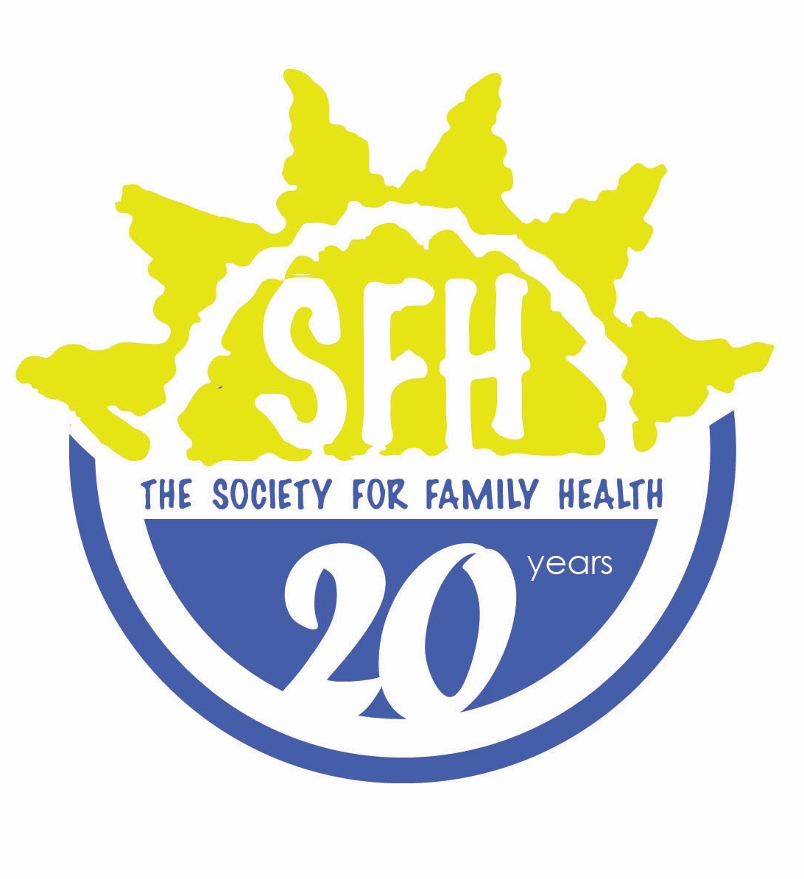

POSITION: Administrative assistant
LEVEL OF EFFORT: FULL TIME
SUPERVISOR: REGISTERED NURSE

Roles and Responsibilities:
- Perform front desk duties including greeting clients, providing information on NAPPAs clinical and community services that are available, escorting clients to referred services, providing information on referrals, performing follow up client phone calls and appointment reminders, maintain registers, follow up registers, and client files.
- Daily management and oversight of the NAPPA clinic data systems including CommCare, and ePMS, knowledge of ePMS will be an advantage.
- Entering relevant client level data into NAPPAs monitoring and evaluation systems
- Collaborate closely with regional data manager on weekly and monthly reports
- Responsibility and oversight of the appropriate storage and reporting of clinical consumables
- Assist CBRHAs with report writing and in conjunction with them provide a monthly report
- Collaborate with enrolled nurse, CAPASA and Regional Coordinator on the CBRHAs duties and assist with formulation of activity plans and time sheets
- Type clinic related mails/emails and information
- Keep clinic information/data confidential at all times
- Assist in General Administration of the clinic. E.g. Photocopies, binding of documents, front office duties
- Collaborate in maintenance of quality of care (QOC) standards at the clinic
- Participate in community sensitization and mobilization activities, including outreach services and collaboration with CBRHAs as needed
- Support community development initiatives
- Coordinate monthly, quarterly and annual reports for the clinic, and provide regular feedback and updates to the NAPPA team where necessary.
- Provide support and guidance to volunteers/interns & CBRHAs attached to the designated NAPPA clinic and ensure a positive working environment exists
- Collaborate with local organizations, clinics on hospitals on referral processes and mechanisms to ensure NAPPA clients are able to be linked to appropriate care
- Support ongoing stock management systems and ensure timely order of stock to secure availability of supplies and commodities
- Attend relevant workshops, training events and meetings as requested by the Clinical Services Manager (CSM) and Head of Programs (HOP).
- Provide administrative support for training events when requested by CSM or Head of Programs
- Provide administrative coverage for other NAPPA clinical assistants at the various clinics as required
- Any other duties as it may be required by supervisor

Qualifications
- Grade 12 Certificate
- Excellent problem-solving, decision-making, organizational and communication skills, with ability to prioritize multiple tasks and work effectively in a demanding environment
- Certified as a Rapid Tester
- Excellent interpersonal and communication skills
- Ability to speak English and preferably at least one local language
- Namibia National preferred

