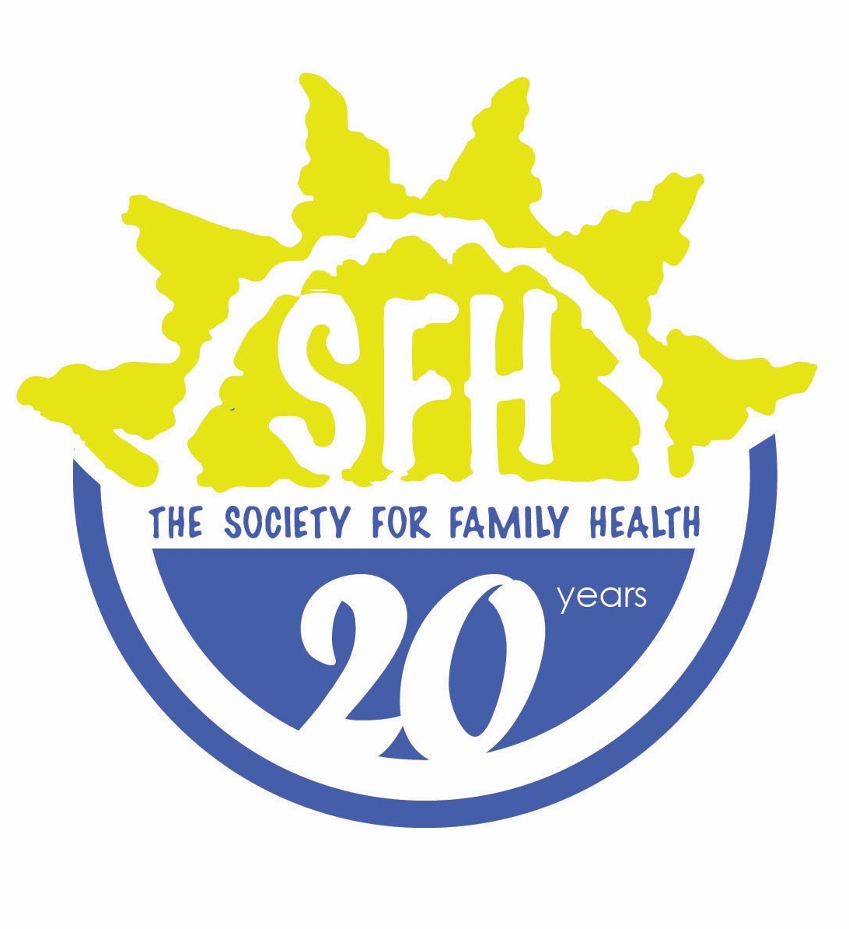

POSITION: COMMUNITY BASED REPRODUCTIVE HEALTH AGENTS (CBRHAs)
LEVEL OF EFFORT: VOLUNTEER
SUPERVISOR: CLINICAL ASSISTANT

Duties/ Key Result Areas:
  - Identify and establish condom distribution points in respective communities
  - Distribute condoms within communities and record the quantities distributed
  - Disseminate information and promote usage of condoms (both male and female) to the general community, giving attention to young people
  - Organize and conduct condom demonstrations, shows/ rallies, with emphasis on correct usage
  - Raise profile of NAPPA through the depiction of banners and other IEC materials
  - Conduct community sensitization and mobilization meetings on the dangers on HIV/AIDS, though training, etc.
  - Sensitize young people on Life skills Education
  - Work as a peer educator with young people in the respective communities on different issues
  - Serve as the communication link between the respective NAPPA Office and the community
  - Compile and submit monthly activity reports to the respective NAPPA Office/ Clinic by the 1st of each month
  - Attend monthly meetings organized by the relevant NAPPA Office/ Clinic
  - Work closely with the NAPPA Office/ Clinic during M&E visits to the community
  - Provide monthly SRH/HIV education based on the organization’s manual for CBRHAs
  - Where appropriate, fill up and report on working conditions of condom dispensers
  - Refer clients (young people, and general public) to NAPPA clinics or in the absence of a NAPPA clinic to Government clinics and other professional facilities.
  - Conduct community/ adolescent health education discussions
  - Mobilize the Community on services offered at NAPPA YFHS Clinics
  - Adhere to all NAPPA policies and regulation, especially when requesting or reporting on funds
  - Any other duty as may be assigned by the respective NAPPA Office/ Clinic
  - Complete daily Clinic attendance register and submit monthly Time sheets for monthly incentives.

