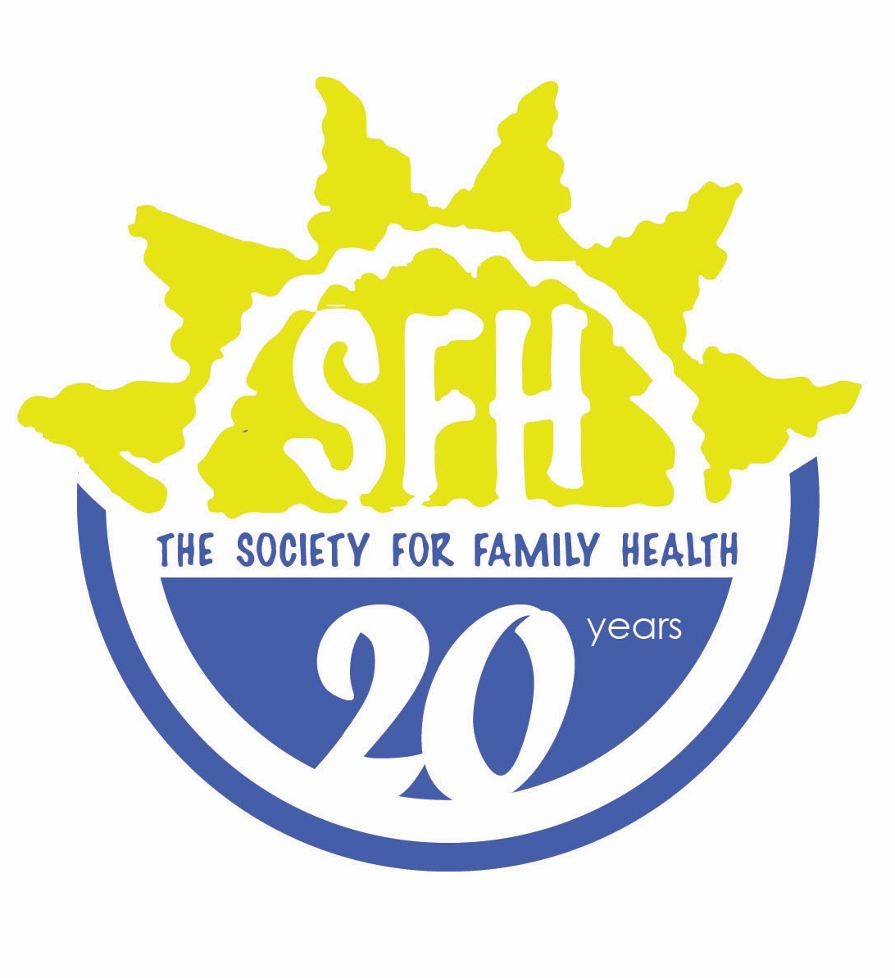

POSITION: Enrolled Nurse
LEVEL OF EFFORT: Full Time
SUPERVISOR: Facility Registered Nurse

Roles and Responsibilities:
- Daily management of the NAPPA clinic, implementing KP and youth friendly sexual, HIV/TB and reproductive health services
- Provision of comprehensive Sexual Reproductive Health (SRH), HIV/TB services at the clinic i.e. information and counseling on SRH issues, HIV prevention, care and treatment, provider-initiated testing and counseling (PITC), family planning services, STI diagnosis treatment, pregnancy testing, ante natal care (ANC) and postnatal care, and any other services introduced by NAPPA at the clinic.
- Management of special cases, such as providing comprehensive SRH services to, amongst others, adolescents, sexual minorities and key populations.
- Initiate, plan, budget control, implementation, monitoring and evaluation of clinic activities
- Maintain quality of care (QOC) standards at the clinic and engage in quality assurance activities.
- Conduct community sensitization and mobilization activities, including outreach services and collaboration with CBHRAs as needed
- Support community development initiatives
- Compile monthly, quarterly and annual reports for the clinic, and provide regular feedback and updates to the NAPPA team where necessary.
- Manage, supervise and provide technical support and guidance to all volunteers/interns & CBRHA’s attached to the designated YFHS clinic and ensure a positive working environment exists
- Provide technical support to clinic-based Youth Advisory Board and youth peer expert patients, in collaboration with NAPPA regional and national staff.
- Ensure ongoing stock management and timely order of stock to secure availability of supplies and commodities
- Advocate on the services that the clinic and Association provides and supports
- Any other duties assigned by RN or CSN

Qualifications
- Certificate in Nursing
- Experience in ART is preferred
- NIMART certification an added advantage
- Valid registration with the Health Professions Council in Namibia
- Excellent problem-solving, decision-making, organizational and communication skills, with ability to prioritize multiple tasks and work effectively in a demanding environment
- Excellent interpersonal and communication skills
- Ability to speak English and preferably at least one local language
- Must be a Namibia National

